ARMA模型预测，为了保证平稳性先用seasonal_decompose函数将时间序列拆分为trend

，seasonal，residual，分别对其进行ARMA建模，确定p，q，得到预测值后再进行相加得到最终的预测结果。

在下面实验中，p，q的取值分别为：

Trend 1,0

Seasonal 1,0

Residual 1,0

滚动预测201509-201608，滑动窗口为1，每次训练数据为当前需预测月份之前的6个月，每次预测1个月。

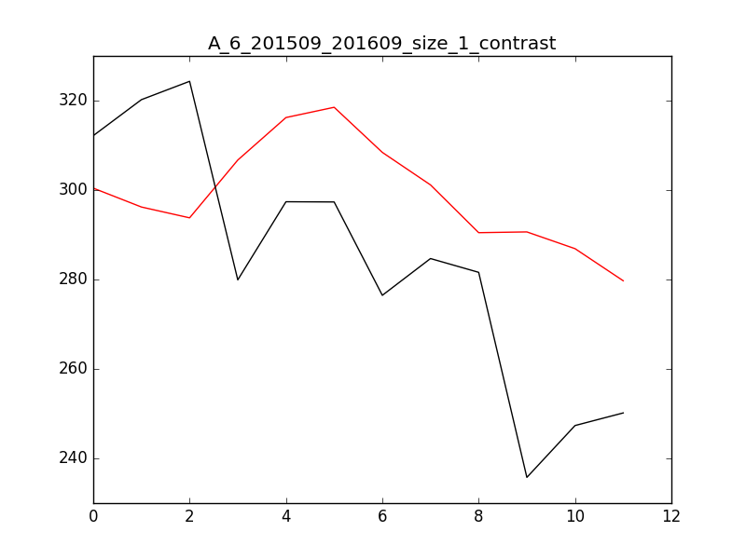

红色为预测值，黑色为实际值，具体数据如下：

201509: 300.431865064 312.164223568 -11.732358504 -3.75839305669%

201510: 296.209750274 320.216716155 -24.0069658814 -7.49709951738%

201511: 293.78982427 324.318952813 -30.5291285422 -9.41330387184%

201512: 306.711096355 279.918411946 26.7926844096 9.57160489133%

201601: 316.213787151 297.387040044 18.8267471074 6.33072211372%

201602: 318.510705203 297.338653353 21.1720518506 7.12051783779%

201603: 308.426505495 276.461195778 31.965309717 11.5623133391%

201604: 301.152947789 284.684699341 16.4682484476 5.78473254293%

201605: 290.471432734 281.602107366 8.86932536887 3.14959481371%

201606: 290.640058369 235.751433269 54.8886251005 23.2824141679%

201607: 286.895859478 247.345597846 39.5502616316 15.9898789289%

201608: 279.71867624 250.163619758 29.5550564824 11.8142903876%

预测：

201609: 267.527645834

滚动预测201509-201608，滑动窗口为3，每次训练数据为当前需预测月份之前的6个月，每次预测3个月。

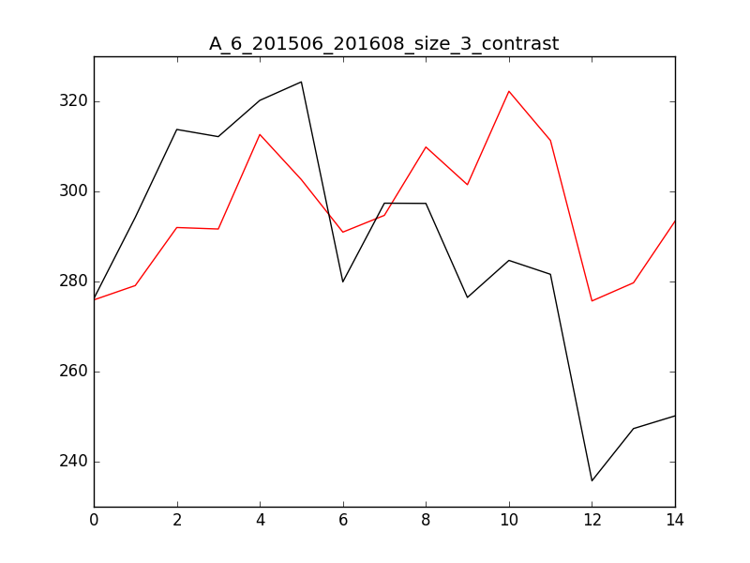

红色为预测值，黑色为实际值，具体数据如下：

201509: 300.431865064 312.164223568 -11.732358504 -3.75839305669%

201510: 300.431861579 320.216716155 -19.7848545763 -6.17858268421%

201511: 300.431862889 324.318952813 -23.887089924 -7.36530804532%

201512: 306.711096355 279.918411946 26.7926844096 9.57160489133%

201601: 306.711096449 297.387040044 9.32405640536 3.13532708217%

201602: 306.711096413 297.338653353 9.37244306087 3.15211054977%

201603: 308.426505495 276.461195778 31.965309717 11.5623133391%

201604: 308.426505479 284.684699341 23.7418061375 8.33968463793%

201605: 308.426505485 281.602107366 26.8243981195 9.52563827395%

201606: 290.640058369 235.751433269 54.8886251005 23.2824141679%

201607: 290.640058373 247.345597846 43.2944605274 17.5036309133%

201608: 290.640058372 250.163619758 40.4764386139 16.179985984%

预测：

201609: 267.527645834

滚动预测201509-201608，滑动窗口为1，每次训练数据为当前需预测月份之前的12个月，每次预测1个月。

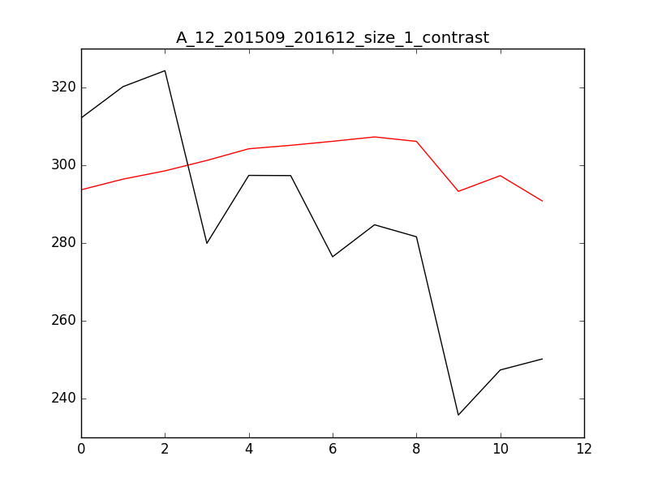

红色为预测值，黑色为实际值，具体数据如下：

201509: 293.686351257 312.164223568 -18.4778723104 -5.91927931369%

201510: 296.428807321 320.216716155 -23.7879088337 -7.42869051914%

201511: 298.557292905 324.318952813 -25.7616599082 -7.94331003007%

201512: 301.240831879 279.918411946 21.3224199329 7.61736957017%

201601: 304.23824221 297.387040044 6.8512021662 2.30379984453%

201602: 305.12416203 297.338653353 7.78550867705 2.6183977728%

201603: 306.157996926 276.461195778 29.696801148 10.7417610867%

201604: 307.281578502 284.684699341 22.5968791611 7.93751094225%

201605: 306.137981917 281.602107366 24.5358745513 8.71295842948%

201606: 293.285229041 235.751433269 57.5337957725 24.4044309613%

201607: 297.320677303 247.345597846 49.9750794569 20.204555849%

201608: 290.832951424 250.163619758 40.6693316657 16.25709274%

预测：

201609: 284.110820473

滚动预测201509-201608，滑动窗口为3，每次训练数据为当前需预测月份之前12个月，每次预测3个月。

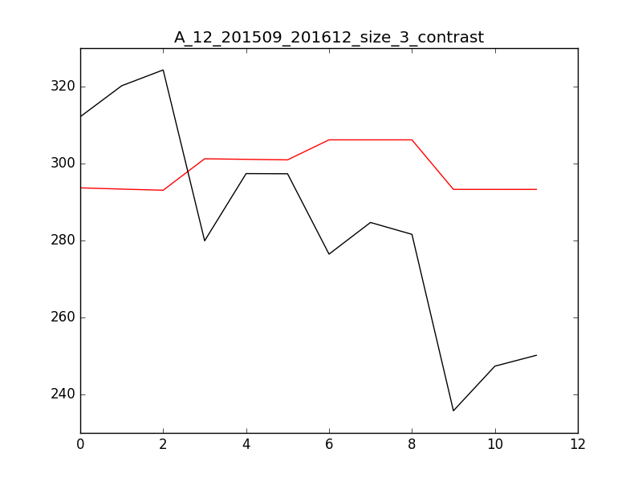

红色为预测值，黑色为实际值，具体数据如下：

201509: 293.686547797 312.164223568 -18.4776757706 -5.91921635331%

201510: 293.356432155 320.216716155 -26.8602839999 -8.38815797076%

201511: 293.065414822 324.318952813 -31.2535379905 -9.63666715109%

201512: 301.240722993 279.918411946 21.3223110467 7.61733067092%

201601: 301.091514975 297.387040044 3.70447493117 1.24567463687%

201602: 300.958671969 297.338653353 3.62001861679 1.21747326692%

201603: 306.158183592 276.461195778 29.6969878141 10.7418286065%

201604: 306.154568293 284.684699341 21.4698689516 7.54163079408%

201605: 306.15188043 281.602107366 24.5497730643 8.71789394403%

201606: 293.285351839 235.751433269 57.5339185705 24.4044830493%

201607: 293.281381305 247.345597846 45.9357834586 18.5714982836%

201608: 293.277411144 250.163619758 43.1137913865 17.2342371078%

预测：

201609: 284.110757752